**Calling python script through ajax call from HTML**

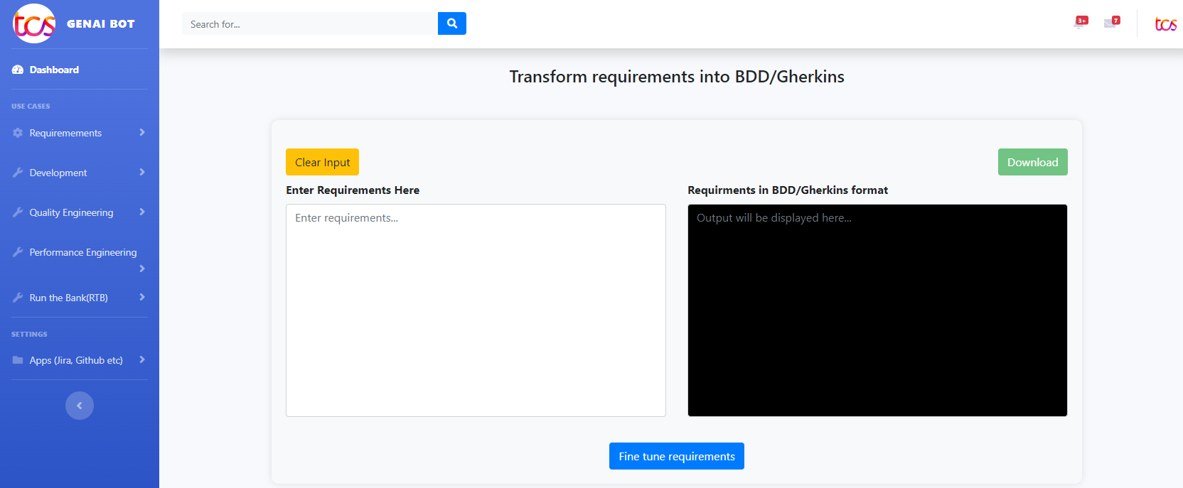

function runPythonScript() {

document.getElementById('loadingSpinner').style.display = 'inline-block';

var pythonScriptPath = "Python.py";

var inputText = document.getElementById('inputTextArea').value;

// Make an AJAX request to your Flask server

fetch('./run_script', {

method: 'POST',

headers: {

'Content-Type': 'application/json',

}

**Python file**

import openai

import argparse

# Set up OpenAI API key

openai.api_key = xyz

openai.api_base = 'Azure URL'

openai.api_type = 'Instance name'

openai.api_version = ‘api version’

deployment_name = 'Deploymentment'

output_file = "Requirement_UI.txt"

# Function to generate test cases using OpenAI GPT-3

def generate_test_cases(description_to_append):

prompt = description_to_append

response = openai.Completion.create(engine=deployment_name, prompt=prompt, temperature=0.0, max_tokens=2000)

with open('scripts/code_optimization/optimized_code.txt') as f:

content = f.read()

print(content)